Slide 1

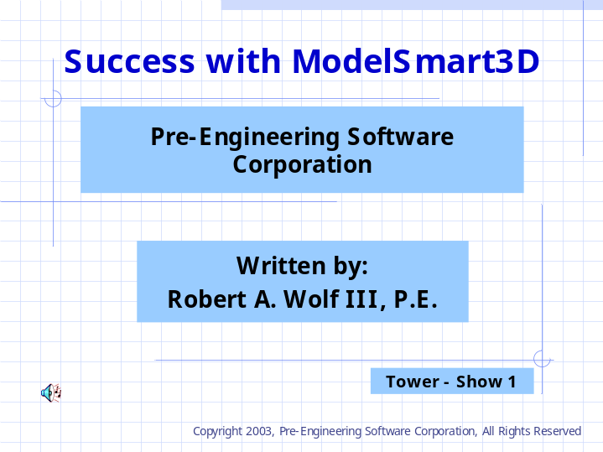

This series of slide shows was prepared for parents and teachers of technology students.
It provides a method to introduce students to structural engineering design.
Structural considerations for the design and construction of model towers is discussed and an example is presented.

Copyright 2003-2004, Pre-Engineering Software Corporation
All rights reserved

Contact:
Robert A. Wolf III, P.E.
5800 One Perkins Pl Dr - STE 10 D
Baton Rouge, LA 70808
(225) 769-3728
www.pre-engineering.com

Slide 2

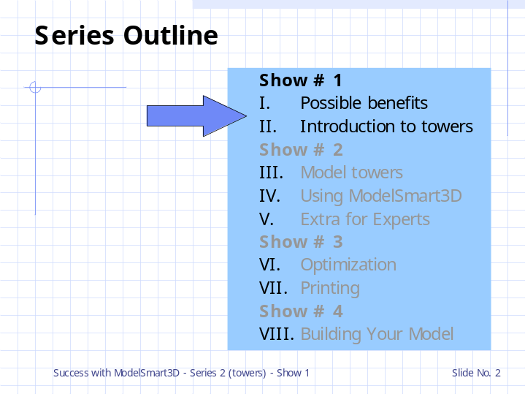

Possible benefits
The reasons for using school time to introduce this topic.
Introduction to towers
A suggested method for introducing towers.

Slide 3

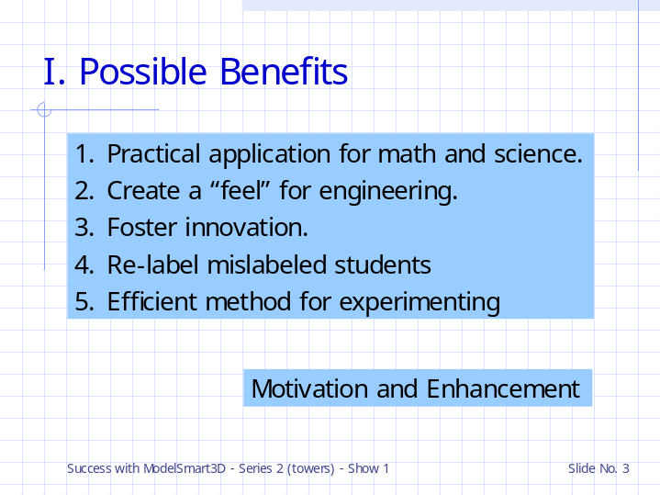

1.
Structural analysis and ModelSmart3D provide opportunity to reinforce math concepts such as:
inequalities, negative numbers, the 3d Cartesian system (x,y,z) ,measurement,% and many others.
For example, a basic engineering design equation states,”
The actual force in a member must be less than or equal to (≤) the allowable force for the member.”
This makes a great practical example for inequalities and wets the appetite for engineering tools (ie math and science).

Structures also provides practical application for science concepts such as implementation of Newton’s laws and other Physical science skills.

2.>>>>>
Also as an added benefit the student will spend time pondering engineering concepts.
This leaves the student with a “feel” for engineering.
This is an advantage for college bound students planning academic studies in engineering.
They attend their classes with a cup ready to be filled.

3.>>>>>
At what age did the inventors of mathematics, science and engineering make most of their discoveries? Early on. Now is the time to provide the math, science and engineering tools for our most inventive young minds.

4.>>>>>
Children live up to their labels. Visually oriented students that are weak in their verbal skills are sometimes, along the way, labeled as poor students.
They are our Engineers!!
We can properly re-label these students using their success with this topic.

5.>>>>>>
We need to learn to do more and more with less and less until we can do everything with nothing.
Buck Minster Fuller
Supplies are expensive.
ModelSmart3D makes it easy to try ideas without wasting materials.
ModelSmart3D can give you vast tower building experience in a morning.

Slide 4

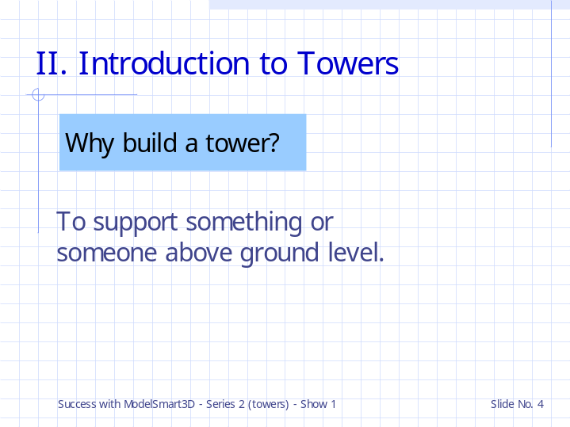

Why build a tower?
To support something or someone above ground level.

Slide 5

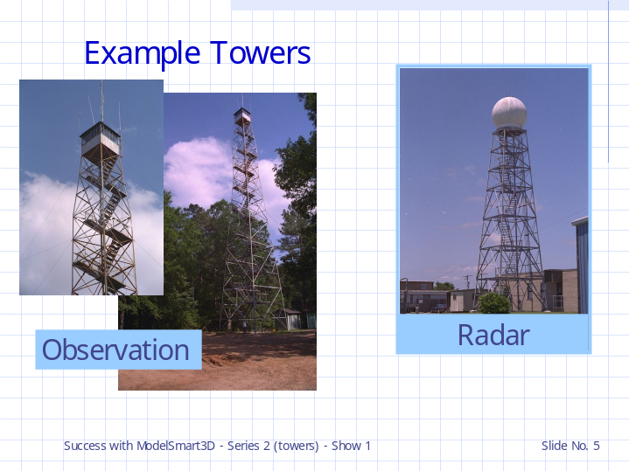

Examples

This observation tower supports forestry personnel above the tree tops to look for forest fires.
Weather radar equipment must be located above obstructions to function properly.

Slide 6

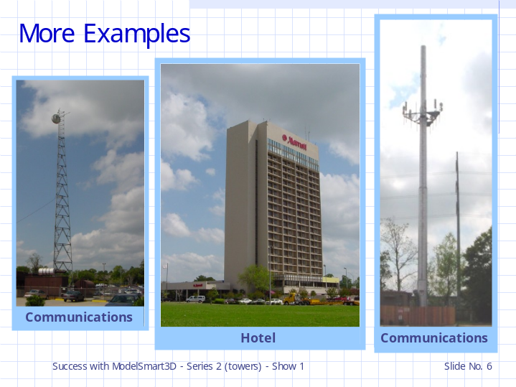

The range of some types communications are greatly effected by the height of the equipment.

Hotels are sometimes located in areas where the cost of the land is high.
A multi-storied tower can lower the land cost per room.

Slide 7

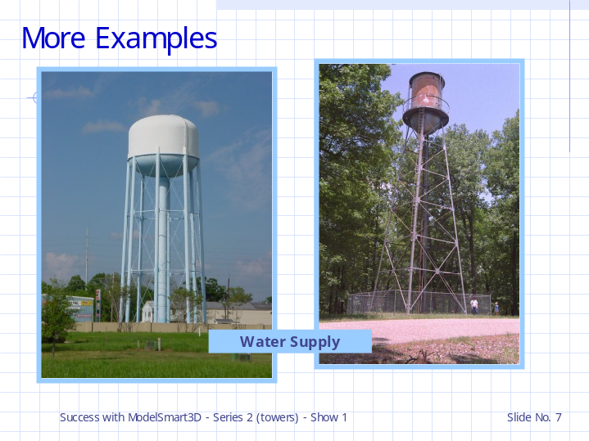

At night ( and other non-peak times) water is pumped from lakes and/or aquifers into towers to help maintain water pressure and provide reserve for fighting fires.

Where are the water towers located in your town?

aq·ui·fer
An underground bed or layer of earth, gravel, or porous stone that yields water.
An underground river.

Slide 8

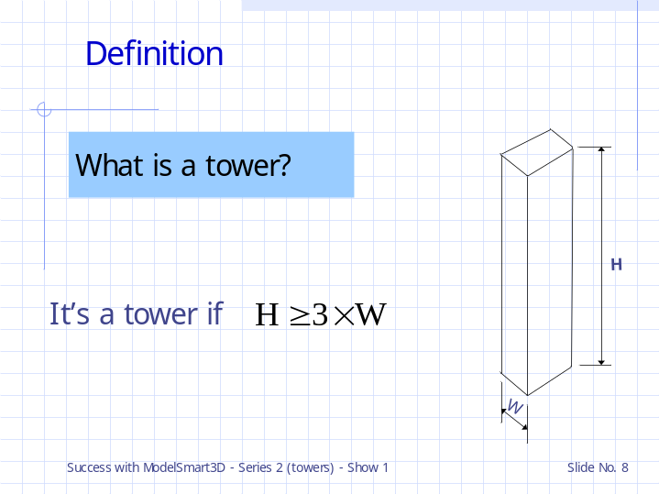

When do ¹engineers consider a structure to be a “tower”?

As a rule of thumb, a structure it considered to be a tower if its height equals or exceeds its least lateral dimension multiplied times three (3) .

¹ The design of towers is usually taught in college structural engineering courses under the department of Civil Engineering.
If you would like to become a structural engineer this usually means that you will major in Civil Engineering and take
structural engineering courses as your engineering electives. After receiving a “Bachelor of Science” degree,
many students go on to get a “Masters Degree” in Structural Engineering.

To become licensed to practice structural engineering
you will nee to take the “Engineer in Training” test (usually during your senior year in college) and then apprentice with a
licensed professional engineer for 4 year to be eligible to take the PE licensing exam.
Additionally most licensing boards require 15 hrs. of continuing education each year after you receive your license.

Slide 9

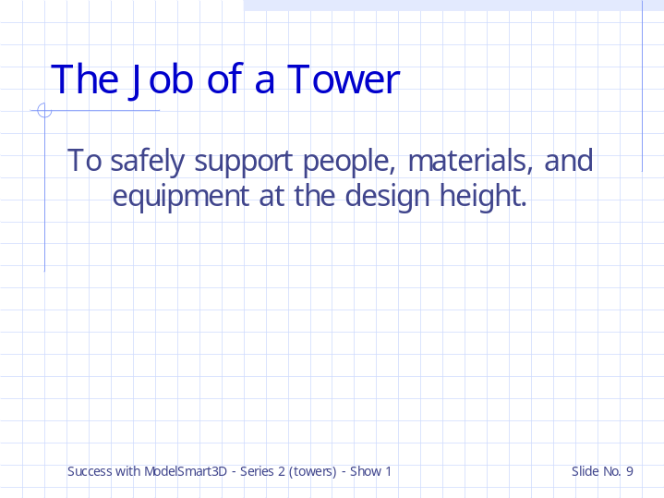

What is meant by support?
Resist failure due to collapse or excessive movement.
Too much movement might give the occupants motion sickness or cause pieces of the building to fall off.
Also, equipment could become misaligned.
It might even collapse!

What is trying to cause collapse or movement of structure?
The loads.

Slide 10

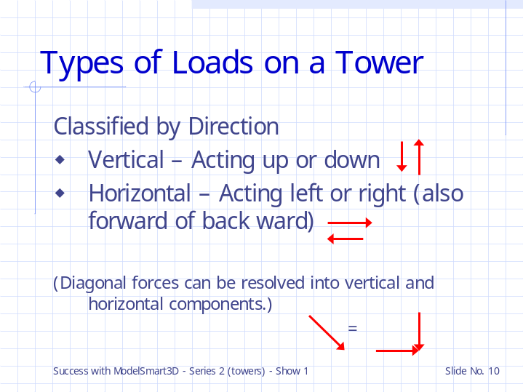

We can divide the loads on a tower into two basic categories – those acting vertical and those acting horizontal.

Slide 11

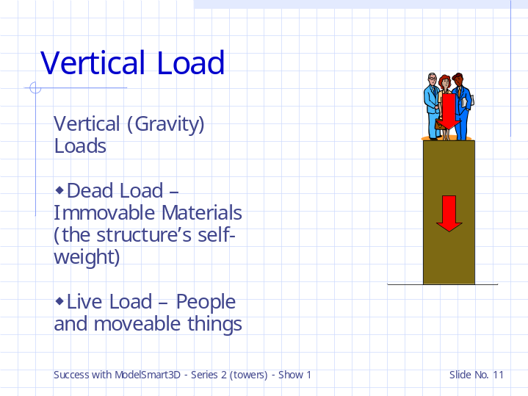

Vertical (or Gravity Loads) are usually divided up into two types – dead load and live load.

Dead load:
Structure self-weight
Permanent equipment (A/C unit or furnace, etc.)

Live Loads:
People
Snow loads
Moveable walls
Moveable equipment
Constructions loads – piled up roofing materials.
Water in a water tower.

Slide 12

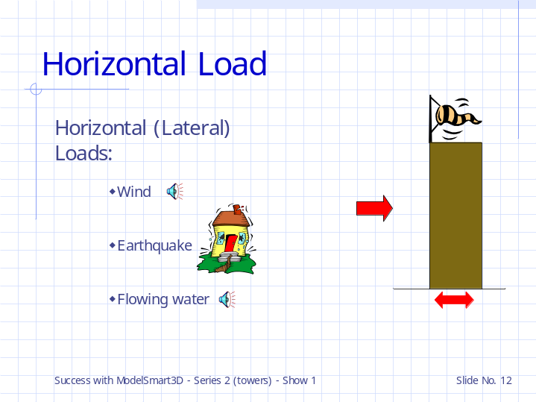

Wind
Hurricanes
We could use a leaf blower to create the wind load on our model – wear eye protection and do not attempt this without proper adult supervision.

Horizontal or Lateral Loads:
Wind forces:
storms
hurricane winds
Tornado? (It depends on the importance of the structure. You would consider it in the design Nuclear Power Plant.
It is usually not cost effective to design a house or normal commercial building to resist the forces of a tornado.
A storm shelter can be used to provide life safety.)

Earthquake forces
Slippage in the tectonic plates under the ground create seismic waves that accelerate a towers foundation.

Flowing Water
Tidal surge (hurricane) or flood waters (rivers out of their banks)
river flow on bridge piers (ie the foundations of bridge support towers)

Slide 13

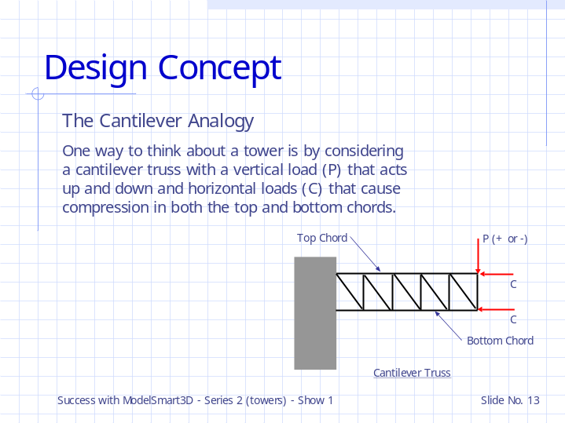

Sometimes it helps to think of a tower in terms of the familiar beam.

Here (if the tower was standing up ) “P” would be the wind or other lateral force and the “C” forces would be the people or other vertical load.

Slide 14

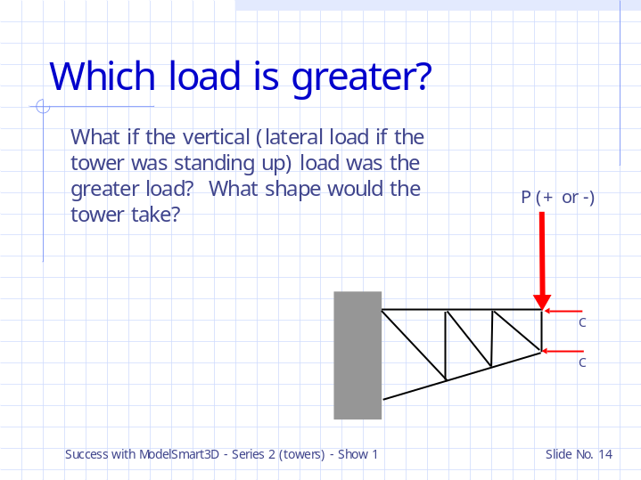

If you were a tower trying to resist lateral load with your body you might spread your feet apart an lean into the load.

Slide 15

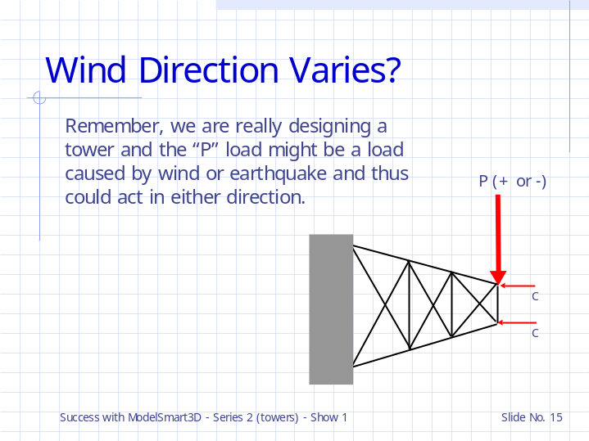

If the load came come from either direction you might center the main part of your body over the placement of your feet.
If the lateral load comes from the front or back you’re out of luck – you don’t have any more feet (ie columns).

Slide 16

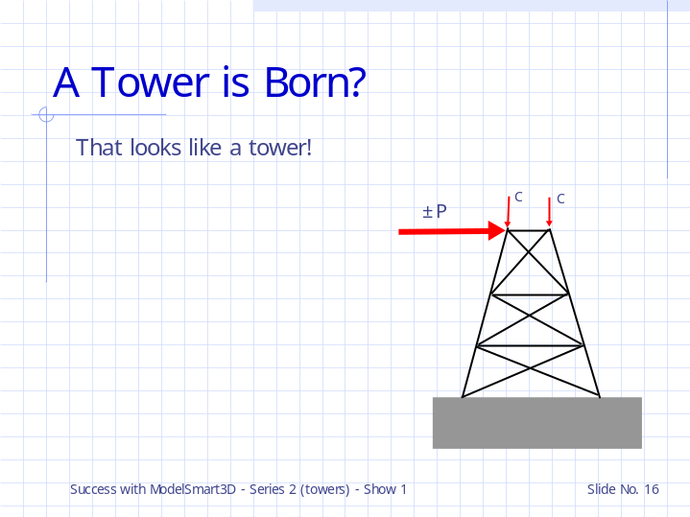

A tower shape for supporting large lateral loads.

Think about towers that support electrical lines.
Wires don’t weight much but the wires and tower members can catch a lot of wind in a storm.

Slide 17

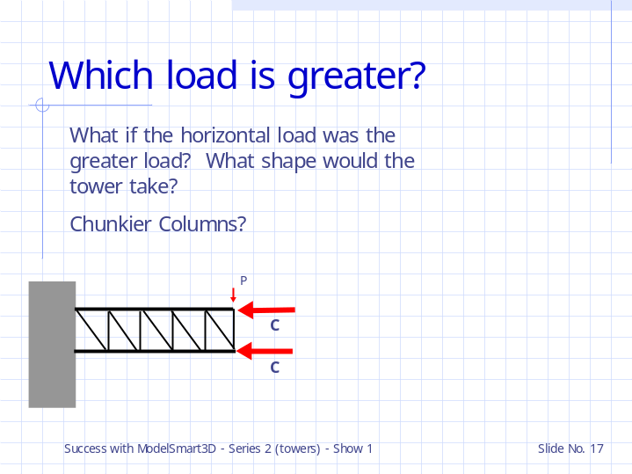

Generally the columns will be the heavier members.

Slide 18

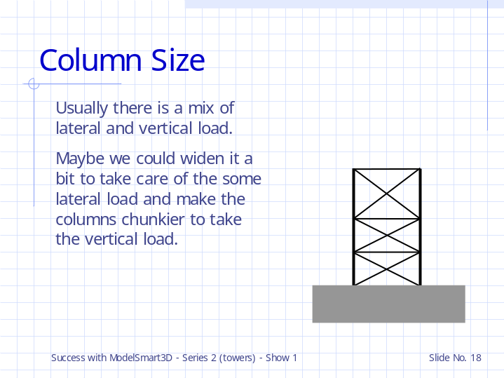

The ratio of the vertical load to the lateral load helps to determines if the columns should be straight or sloped.
(Sloped column towers are harder and more expensive to design and build due to the complexity of the connection details. You might want to consider this when planning your model.)

What about the location of the horizontals in the tower. How many levels of bracing should we have?

Slide 19

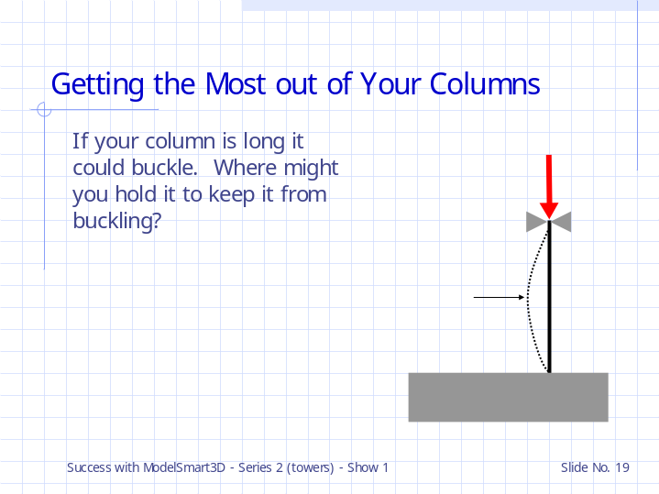

You would probably want to brace it in the middle.

Slide 20

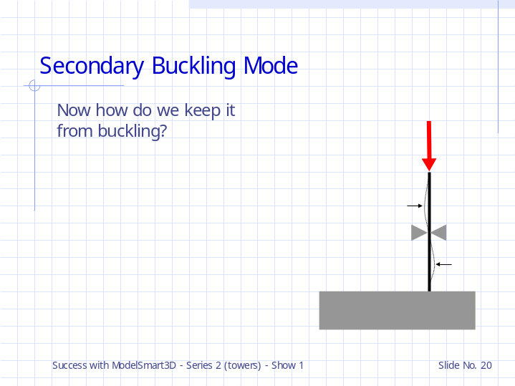

Now we have to brace it at two other locations - in the middle of the two un-braced segments.

Slide 21

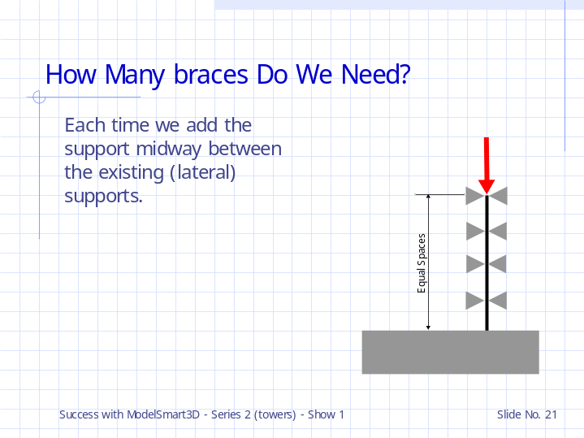

Generally the distance between lateral supports (ie levels) should be equal (especially in towers with lots of gravity load).
But how many should we have?
To answer this we need to know how columns can fail.

Slide 22

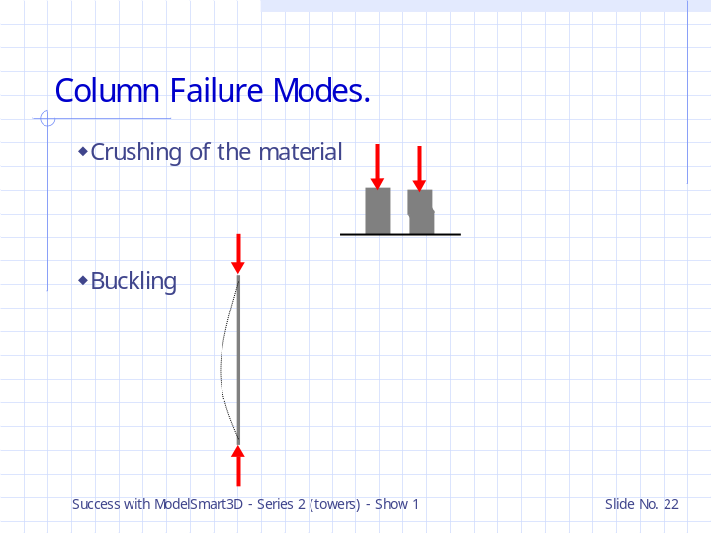

Short columns fail by a crushing of the material.

Long columns fail by buckling.

Slide 23

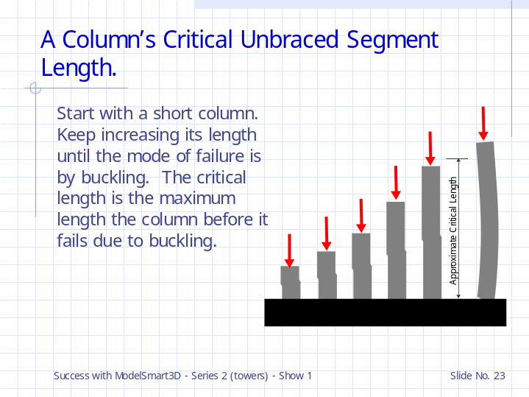

In the sketch we are assuming lateral support as the top and bottom of the column.

Slide 24

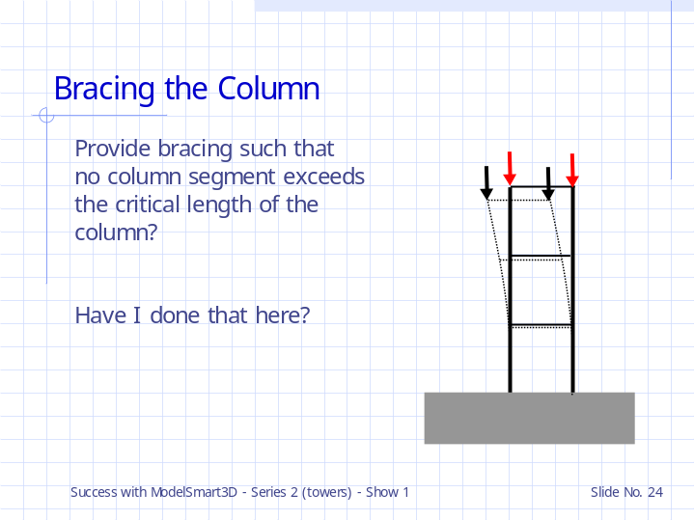

That is, to be able to support the greatest amount of load on a column provide lateral bracing
at intervals equal to or less than the critical length.

Providing “lateral bracing at intervals equal to or less than the critical length” may or may not result in an efficient tower.
Sometimes you can save structure weight by omitting a bracing level if you don’t need the full strength of the column – this is an arrangement that you can experiment with. You will do this when you try to optimize (make as efficient as possible) your design.

Here I have made sure that both columns fail at the same time – the connection of the horizontal member to the column is usually not adequate enough to provide lateral support.

Slide 25

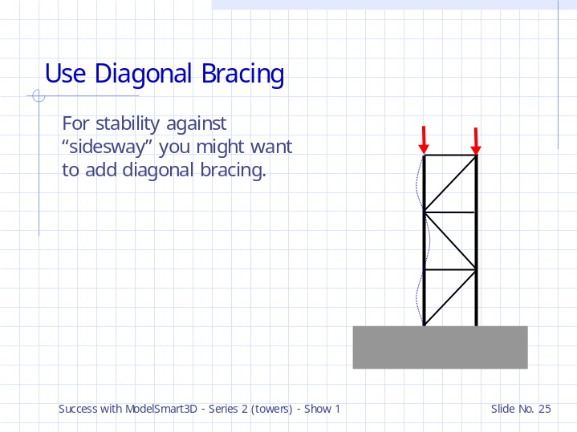

And don’t forget you must also brace the tower in the other direction (into the screen).

Slide 26

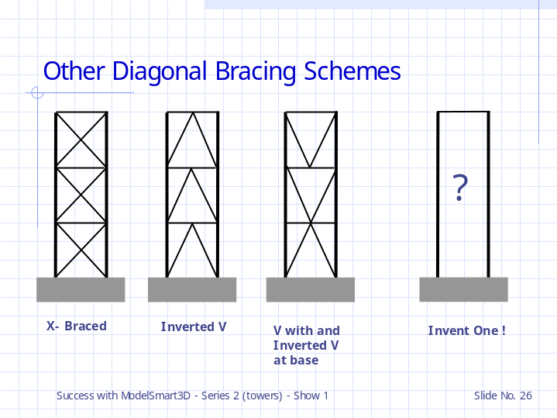

Other bracing arrangements.

Can you invent one?

Slide 27

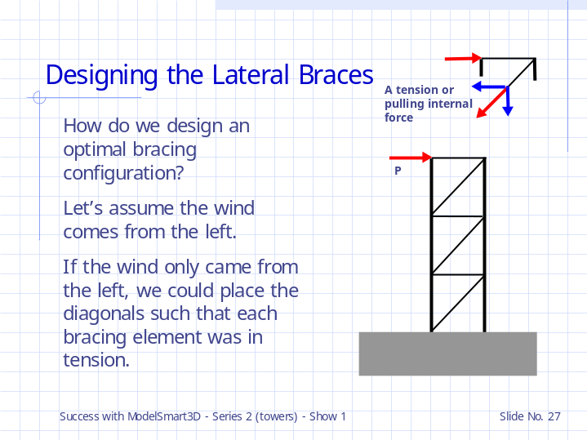

Tension members don’t buckle so we could make these bracing member quite slender and thus lighter.

Slide 28

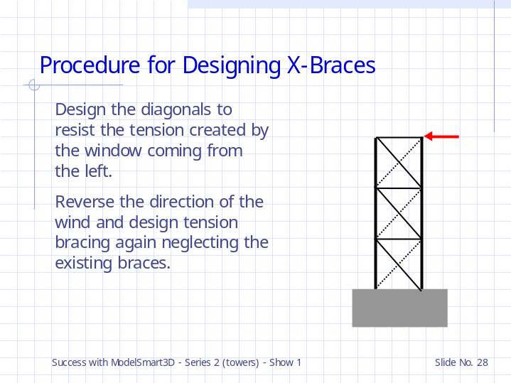

But the wind usually blows in both directions.

When you reverse the lateral load direction you can usually neglect the compression capacity of the slender member ( that is really there ) because it will buckle at such a small load and will not bend out so much that it fails.
(We have a special feature in the program that allows you to temporarily negate a member.)

You may find that when you are looking at the capacity of the tower the shortening of the columns due to an ultimate load may causes the diagonals to appear to fail in compression. If the compression force is very small you could negate these members to get the true capacity of the tower assuming that the braces will still be able to provide support in tension when needed.
(That is, provided the diagonals don’t fail by rotating the connections to far. The program can give you guidance on joint movements.)

The lateral force on a model tower might be caused by placing the test load just off center or by not constructing it perfectly straight – this would create the effect of a lateral load.

As a rule, you need to provide some lateral load so that ModelSmart3D have something to work with.
Try putting a couple of horizontal loads (a pound or two) at the top joints of the tower and check how sensitive your tower is to this type of force.

You can use this fictitious load to keep some of the diagonals in tension while you negate others.

Slide 29

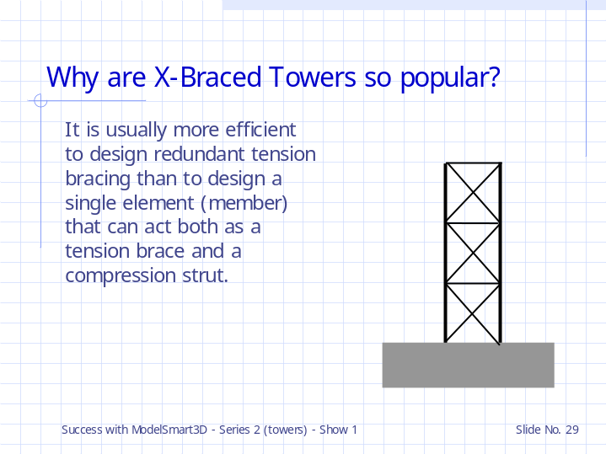

We’ll look more at the behavior of model towers in the next show.

Slide 30



